ST.XAVIER’S COLLEGE

(Affiliated to Tribhuvan University)

Maitighar, Kathmandu



**Artificial Intelligence Lab Assignment #6**

**SUBMITTED BY:**

Pradeep Dahal

017BSCIT029

2nd Year/4th Sem

|  |  |
| --- | --- |
| **SUBMITTED TO:** |  |

|  |  |  |
| --- | --- | --- |
|  | **Signature** | **Remarks** |
| **Mr. Bal Krishna Subedi**  **Lecturer, Dept. of Computer Science** |  |  |

**Question**:

Write a prolog program to trace path in given graph.

**Source Code:**

edge(s,a).

edge(s,b).

edge(a,c).

edge(a,d).

edge(b,d).

edge(c,d).

edge(c,g).

edge(d,g).

path(A,B):-edge(A,B).

path(X,Z):-edge(X,Y),edge(Y,Z).

path(W,Z):-edge(W,X),edge(X,Y),edge(Y,Z).

**Tracing Output:**

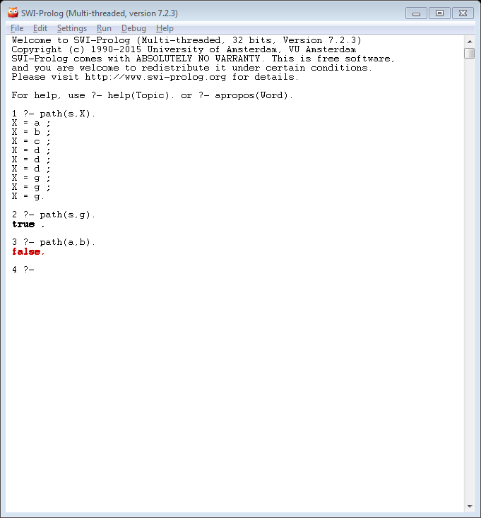

**Conclusion:**

In this way, through the program, path was traced.